**LAB-8**

1. Write a program that tries to access an element outside the bounds of an array and handles the ArrayIndexOutOfBoundsException by printing a user-friendly message.

Program-

**package** demo4;

**public** **class** ArrayBoundExample {

**public** **static** **void** main(String[] args) {

// **TODO** Auto-generated method stub

**int**[] numbers = {1, 2, 3, 4, 5};

**try**

{

// Attempt to access an element outside the bounds of the array

**int** element = numbers[7];

System.***out***.println("Element at index 7: " + element);

}

**catch** (ArrayIndexOutOfBoundsException e)

{

// Handle the exception by printing a user-friendly message

System.***out***.println("Error: You tried to access an element outside the bounds of the array.");

}

}

}

Output-

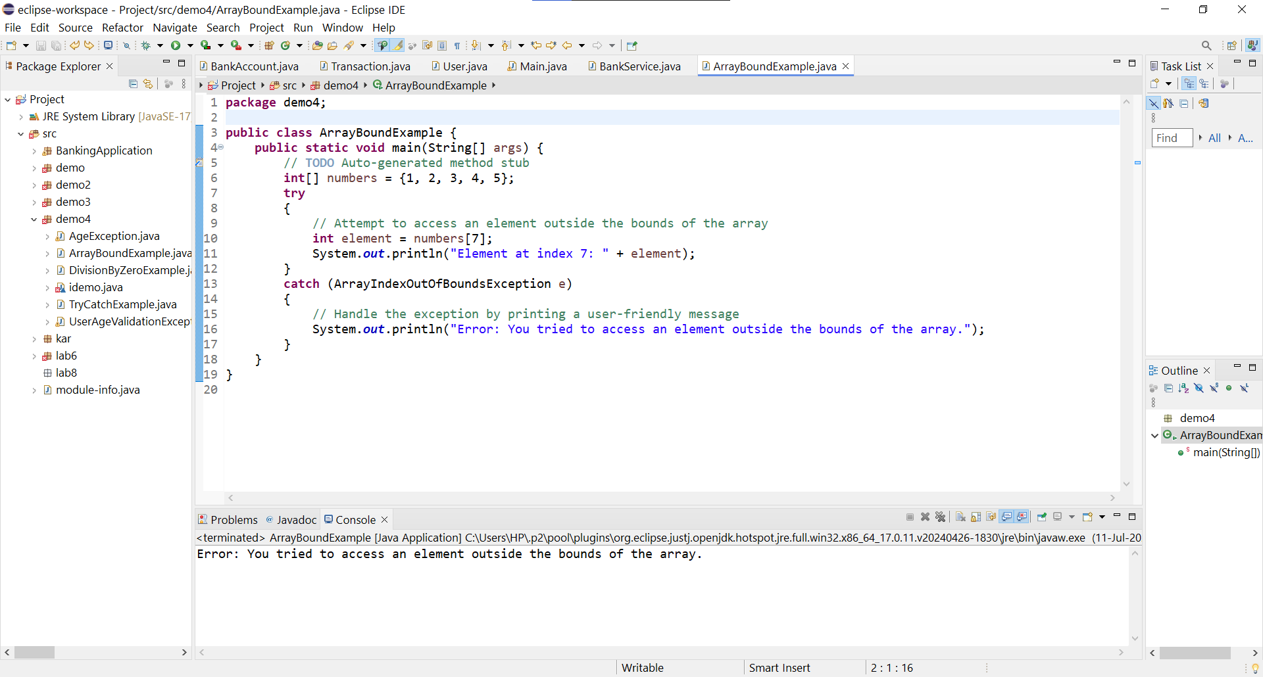

1. Write a program that attempts to divide a number by zero and handles the ArithmeticException by printing a message that division by zero is not allowed.

Program-

**package** demo4;

**public** **class** DivisionByZeroExample {

**public** **static** **void** main(String[] args) {

// **TODO** Auto-generated method stub

**int** n = 10;

**int** d = 0;

**try** {

**int** result = n / d;

System.***out***.println("The result is: " + result);

}

**catch** (ArithmeticException e) {

System.***out***.println("Error: Division by zero is not allowed.");

}

}

}

Output-

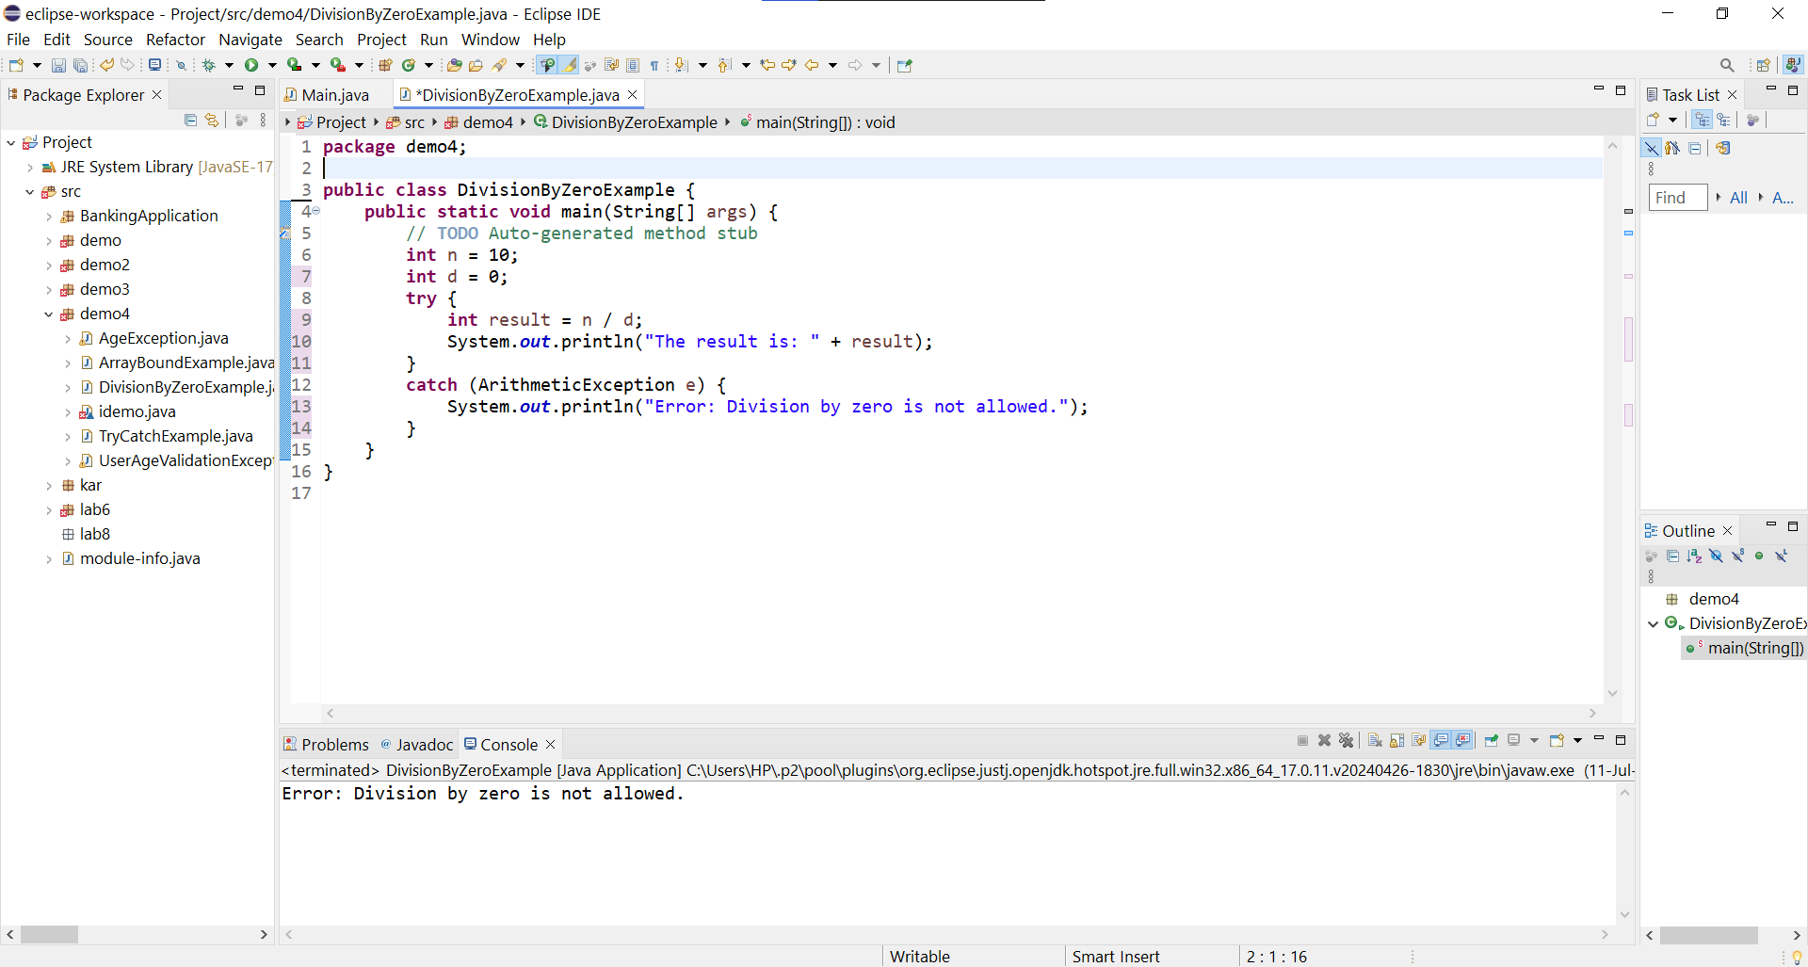

1. Write a Java program that reads an integer input from the user and throws an IllegalArgumentException if the input is negative. Display an appropriate message when the exception is caught.

Program-

**package** lab8;

**import** java.util.Scanner;

**public** **class** NegativeInput {

**public** **static** **void** main(String[] args) {

// **TODO** Auto-generated method stub

Scanner sc = **new** Scanner(System.***in***);

System.***out***.print("Enter an integer: ");

**try** {

**int** input = sc.nextInt();

*checkForNegativeInput*(input);

System.***out***.println("You entered: " + input);

} **catch** (IllegalArgumentException e) {

// Handle the exception by printing a user-friendly message

System.***out***.println("Error: Negative input is not allowed.");

} **finally** {

sc.close();

}

}

**public** **static** **void** checkForNegativeInput(**int** number) {

**if** (number < 0) {

**throw** **new** IllegalArgumentException("Negative number: " + number);

}

}

}

Output-

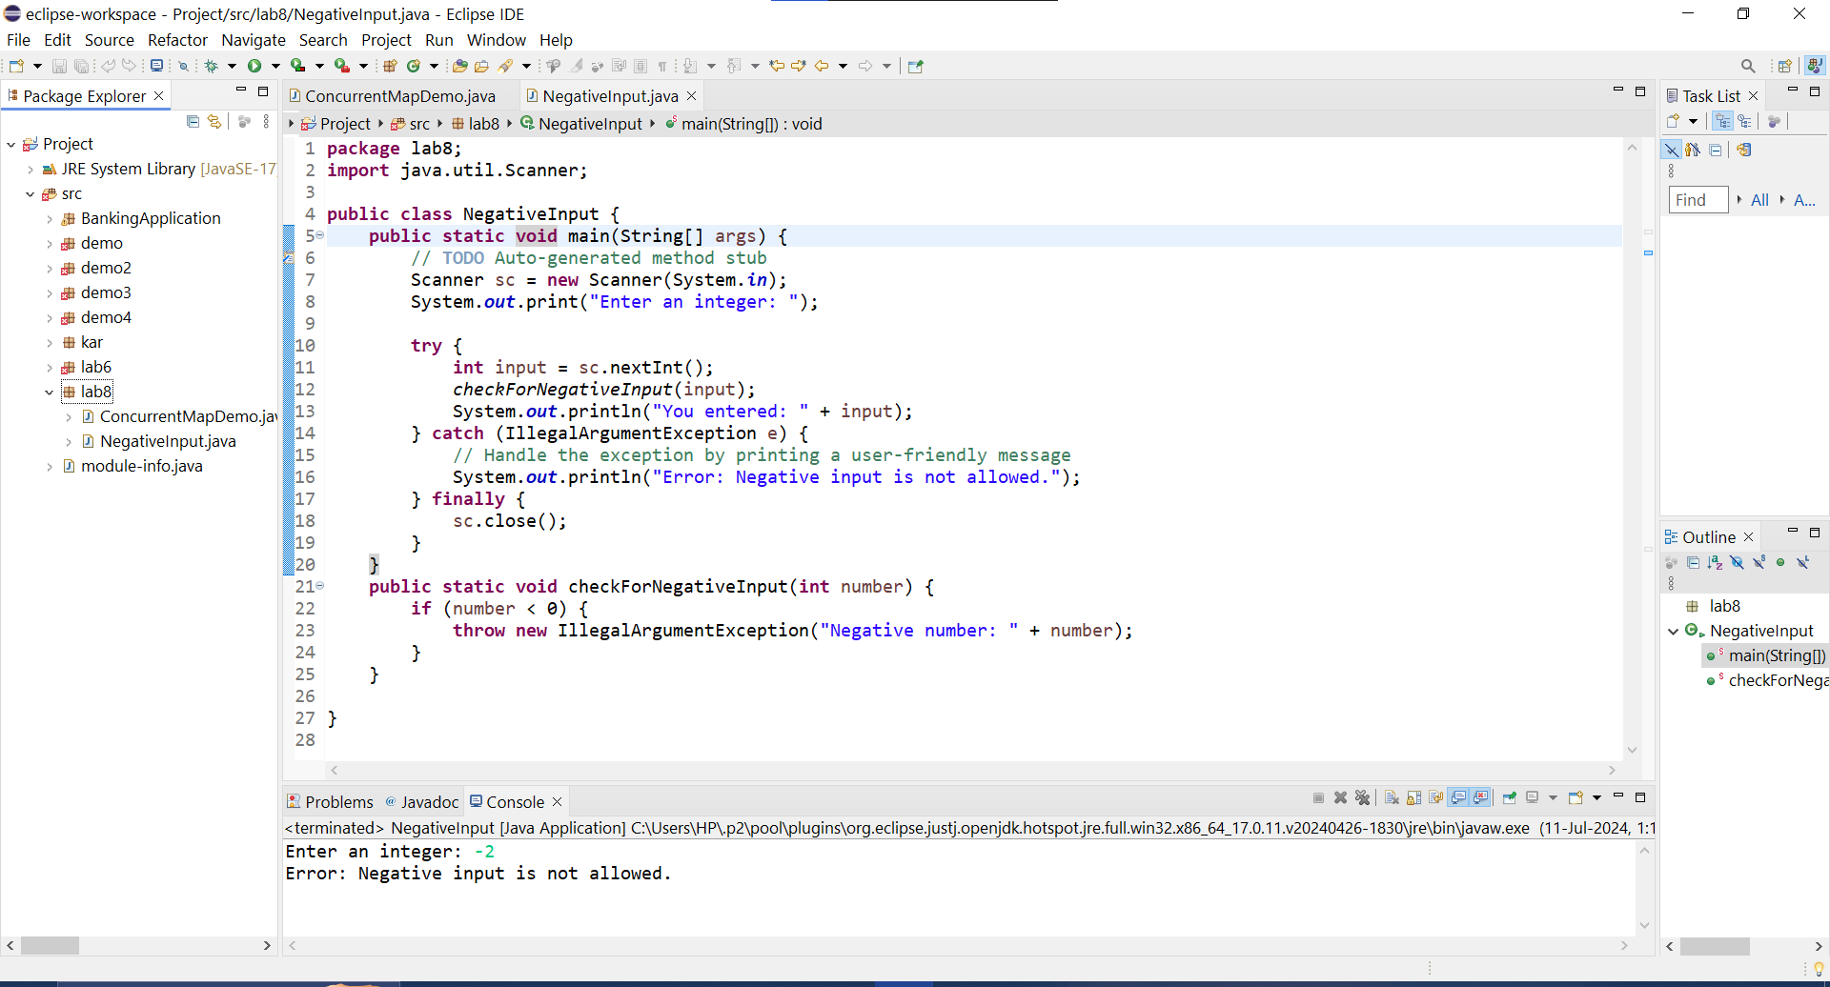

1. Define a custom exception called InvalidAgeException. Write a Java program that throws this exception if the age provided is less than 18. Handle the exception and display an appropriate message.

Program-

**InvalidAgeException.java-**

**package** lab8;

**public** **class** InvalidAgeException **extends** Exception

{

**public** InvalidAgeException(String message) {

**super**(message);

}

}

**AgeValidator.java -**

**package** lab8;

**import** java.util.Scanner;

**public** **class** AgeValidator {

**public** **static** **void** main(String[] args) {

// **TODO** Auto-generated method stub

Scanner sc = **new** Scanner(System.***in***);

System.***out***.print("Enter your age: ");

**try** {

**int** age = sc.nextInt();

*validateAge*(age);

System.***out***.println("Age entered: " + age);

} **catch** (InvalidAgeException e) {

// Handle the custom exception by printing a user-friendly message

System.***out***.println("Error: " + e.getMessage());

} **finally** {

sc.close();

}

}

**public** **static** **void** validateAge(**int** age) **throws** InvalidAgeException {

**if** (age < 18) {

**throw** **new** InvalidAgeException("Age must be 18 or older ");

}

}

}

Output-

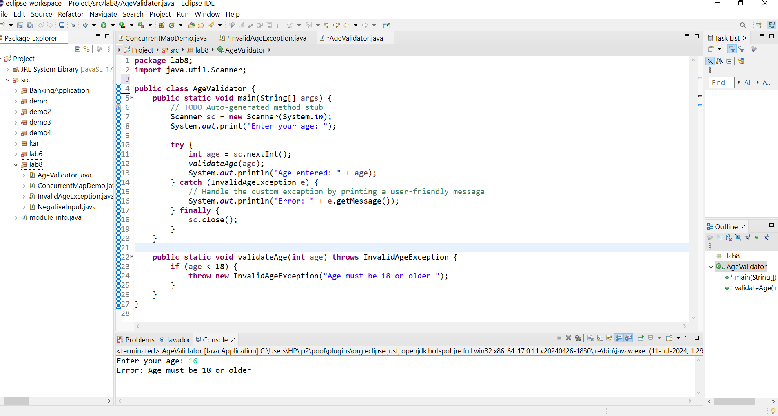

1. Write a Java program that has a method to validate a user's email address. The method should throw a custom exception InvalidEmailException if the email does not contain @ and .. Handle the exception in the main method.

Program-

**InvalidEmailException.java-**

**package** lab8;

**public** **class** InvalidEmailException **extends** Exception {

**public** InvalidEmailException(String message)

{

**super**(message);

}

}

**EmailValidator.java-**

**package** lab8;

**import** java.util.Scanner;

**public** **class** EmailValidator {

**public** **static** **void** main(String[] args) {

// **TODO** Auto-generated method stub

Scanner sc= **new** Scanner(System.***in***);

System.***out***.print("Enter your email address: ");

**try** {

String email = sc.nextLine();

*validateEmail*(email);

System.***out***.println("Email entered: " + email);

} **catch** (InvalidEmailException e) {

// Handle the custom exception by printing a user-friendly message

System.***out***.println("Error: " + e.getMessage());

} **finally** {

sc.close();

}

}

**public** **static** **void** validateEmail(String email) **throws** InvalidEmailException {

**if** (!email.contains("@") || !email.contains(".")) {

**throw** **new** InvalidEmailException("Invalid email address.");

}

}

}

Output-

